**SRS - DOCUMENT**

Movie website

By: Aya Moutlk

3/7/2023

Contents

Table of Contents 1

SRS- Software Requirements Specification 2

Introduction 2

Purpose of the document 2

Overview of the system 2

Stakeholder requirements 3

Scope 3

Functional Requirements 4

Non-Functional Requirements 4

User Interface 4

Constraints 5

Assumptions 5

Glossary: 5

Conclusion 6

**SRS- Software Requirements Specification**

# Introduction

## Purpose of the document

The purpose of this Software Requirements Specification (SRS) document is to outline the requirements for the "Movies Website" project. The website will be developed will provide users with access to various pages information about some movies and images, video, to ability search, to write review, to alter movie, delete movie, and add movie.

## Overview of the system

In this system will create a database site for movies. Similar to the site of IMDB, but a little bit simpler.

The admin user will be in charge to post movies with the following data:

Poster with image of the movie, A title with the name of the movie, A short description of the movie plot, General information: Director of the movie, Four main actors, Year of release

Home page: On the homepage of the site, will present just the images of movies.

Movie description page: By clicking on a movie image you will be moved to a page with the movie information, Poster with image of the movie, A title with the name of the movie, A short description of the movie plot, General information: Director of the movie, Four main actors, Year of release, The users of the site reviews.

The design of the site: can use HTML, CSS JavaScript files to design the site.

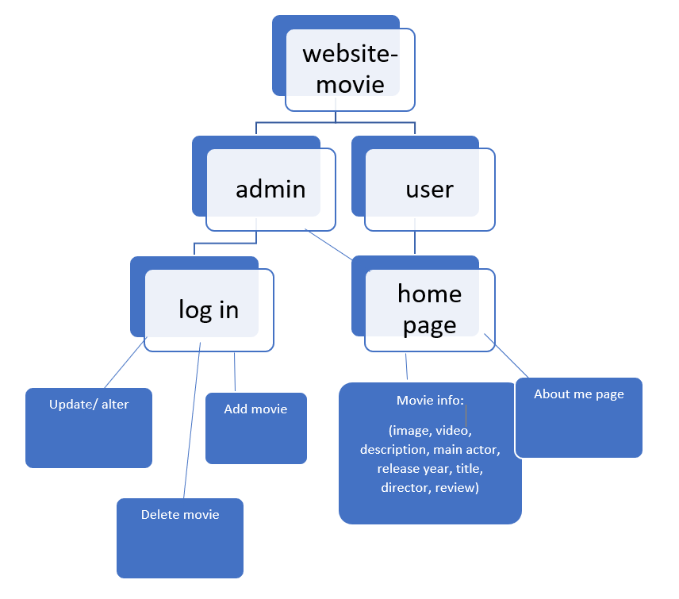

## Stakeholder requirements

The stakeholder requirements of the product/ website: the organization of Samana, and the users.

## Scope

The scope of the Movies Website project includes:

Ensuring that the website is user-friendly and easy to navigate

Implementing security measures to protect user data.

Providing scalability to accommodate potential growth and changes in user traffic

Meeting all applicable web development and accessibility standards

# Functional Requirements

The functional requirements for the Movies Website project include:

A homepage that displays poster to 10 movies, and button to add movie.

A search bar that allows users to search for movie by name the movie (title movie).

Info pages that display movie details, video, images, and review bar (to rating and write comment about the movie)

Button (Alter movie) to modified details about the movie. (update)

## Non-Functional Requirements

The non-functional requirements for the Movies Website project include:

* Usability: The website must be easy to navigate and use, with intuitive user interfaces and clear instructions.
* Performance: The website must load quickly and respond to user actions in a timely manner, even during periods of high traffic.
* Compatibility: The website must be compatible with a range of browsers and devices, including desktop and mobile devices.
* Accessibility: The website must conform to accessibility standards, including providing alternative text for images and support for screen readers.

# Web Admin

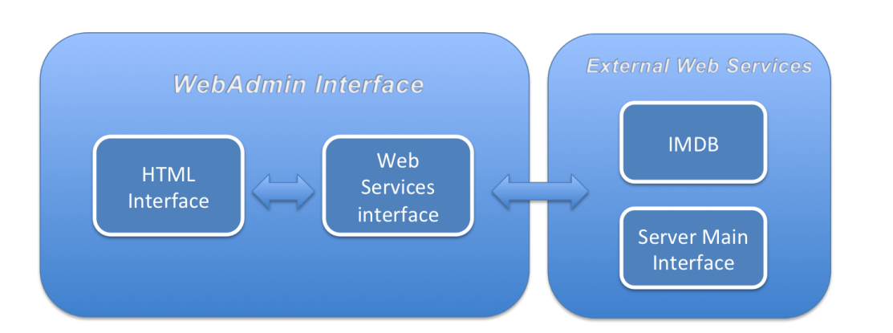

## Admin interface

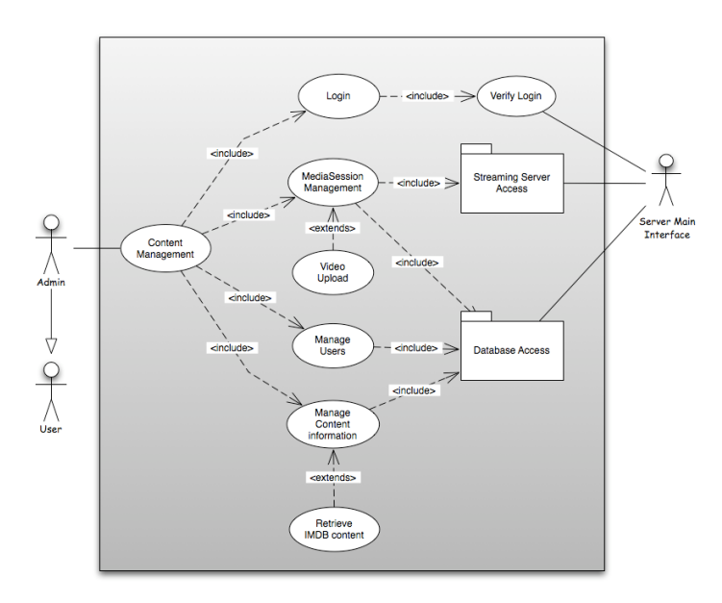

## User Interface

The user interface for the Movies Website project will include:

A clean and modern design with clear typography and layout

Consistent navigation throughout the website

Use of images and multimedia to enhance the user experience

Clear calls-to-action to use the website.

# Constraints

The constraints for the Movies Website project include:

* The website must be developed using HTML, CSS, and JavaScript
* The website must be in flask server
* The project must be completed within the specified timeline and budget
* The website must comply with all applicable laws and regulations

# Assumptions

The assumptions for the Movies Website project include:

Users will have a basic understanding of how to use a web browser and navigate a website

Users will have bar review to write comment and rating to the movie.

# Database access

The data will be saved in the data base from type SQLite, and in this diagram there the explain how use it.

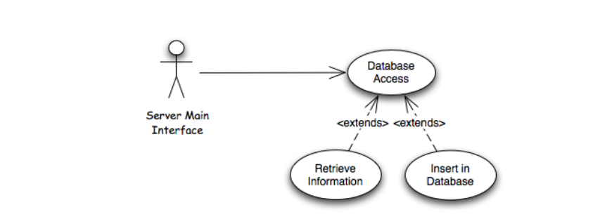

## Acronyms and abbreviations

CSS: Cascading Style Sheets

HTML: Hypertext Markup Language

SRS: Software Requirements Specification

STP: Software Test Plan

STD: Software Test Description

Glossary

Term

# Glossary:

The glossary for the Movies Website project includes:

Glossary

Term Definition

Active Article The document that is tracked by the system; it is a narrative

that is planned to be posted to the public website.

Author Person submitting an article to be reviewed. In case of

multiple authors, this term refers to the principal author,

with whom all communication is made.

Database Collection of all the information monitored by this system.

Editor Person who receives articles, sends articles for review, and

makes final judgments for publications.

Field A cell within a form.

Historical Society Database The existing membership database (also HS database).

Member A member of the Historical Society listed in the HS

database.

Reader Anyone visiting the site to read articles.

Review A written recommendation about the appropriateness of an

article for publication; may include suggestions for

improvement.

Reviewer A person that examines an article and has the ability to

recommend approval of the article for publication or to

request that changes be made in the article.

Software Requirements

Specification

A document that completely describes all of the functions

of a proposed system and the constraints under which it

must operate. For example, this document.

Stakeholder Any person with an interest in the project who is not a

developer.

User Reviewer or Author.

Glossary

Term Definition

Active Article The document that is tracked by the system; it is a narrative

that is planned to be posted to the public website.

Author Person submitting an article to be reviewed. In case of

multiple authors, this term refers to the principal author,

with whom all communication is made.

Database Collection of all the information monitored by this system.

Editor Person who receives articles, sends articles for review, and

makes final judgments for publications.

Field A cell within a form.

Historical Society Database The existing membership database (also HS database).

Member A member of the Historical Society listed in the HS

database.

Reader Anyone visiting the site to read articles.

Review A written recommendation about the appropriateness of an

article for publication; may include suggestions for

improvement.

Reviewer A person that examines an article and has the ability to

recommend approval of the article for publication or to

request that changes be made in the article.

Software Requirements

Specification

A document that completely describes all of the functions

of a proposed system and the constraints under which it

must operate. For example, this document.

Stakeholder Any person with an interest in the project who is not a

developer.

User Reviewer or Author.

|  |  |
| --- | --- |
| **Term** | **Definition** |
| Database | Collection of all the information monitored by this system. |
| Review | A written comment and rating about the movie. |
| SRS – Software requirements specification | A document that completely describes all of the functions of a proposed system and the constraints under which it must operate. For example, this document |
| Stakeholder | Any person with an interest in the project who is not a  developer  Any person with an interest in the project who is not a  developer  Any person with an interest in the project who is not a developer |
| SQLite | SQLite is a lightweight, embedded relational database management system. |
| Flask | Flask is a web framework, it’s a Python module that lets you develop web applications easily. |
| Homepage | The initial page of the website that displays poster for 10 movies. |
| Info pages: | Pages that display detailed information about a specific movie, including video, images, review bar and description. |

# Conclusion

In conclusion, this SRS document outlines the requirements for the Movies Website project, including functional and non-functional requirements, user interface design, constraints, and assumptions. All stakeholders have reviewed and approved this document.